Biology Syllabus
Welcome to Mrs. Lemon’s Biology class!
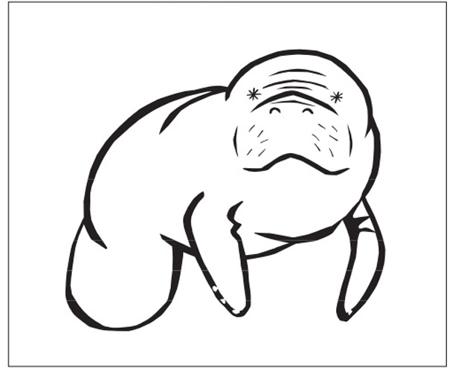
Contact
Mrs. Nicole Lemon, Huron High School
Email: lemonn@aaps.k12.mi.us
Phone: (734) 994-2040 x37538
Website: mrslemonn.weebly.com
Classroom: 5205, Office: 5205B

At Huron High School, the community of sciences promotes a culture of exploration through the development of inquiry, critical thinking, and a sustainable global perspective.

Course Overview
This semester, you will explore many biological concepts! We will start by discussing the inquiry & the scientific method, systems & scale, matter & energy, genetics & inheritance, natural selection & evolution, ecology & human impact.

Supplies
Three ring binder
Lined paper
Scientific calculator
Pencil or pen Donations of tissues and hand sanitizer are greatly appreciated!

Textbook
Biology: Principles and Explorations by HRW. The district has a login and password for you to access the textbook and several ancillary materials at my.hrw.com. Physical textbooks are also available in the book depository for students to check out. You are expected to turn the book in at the end of the year. Failure to return in the same condition may result in fines for repair or replacement.

Website
You can access class resources on the class site at mrslemonn.weebly.com. I will post daily agendas, documents, online simulations, and helpful links on the website.

Expectations
In my classroom, respect is very important. Please treat yourself, your classmates, and your teachers with respect.

Remember that genuine learning involves moments of frustration. This is okay! Don’t give up – try going back to the beginning and looking at things from a different perspective. The greatest learning takes place when you struggle with a problem and find the answer for yourself.

I will do my best to be a good teacher, and I expect you to do your best to be a good student. I will be happy to help you! Please ask questions during class. I am happy to meet one-on-one, just let me know during class or email me if you’d like to set up a time. Don’t wait until you feel overwhelmed to ask for help - be proactive and ask early.

Academic misconduct (cheating, plagiarizing, copying) will not be permitted. If you cheat on an assignment, you will receive a permanent zero on that assignment and will not be allowed to make it up. There will also be disciplinary consequences.

Please use appropriate language in the classroom. The language you use with your friends may not be classroom-appropriate. Racial slurs, hate speech, and bullying are not acceptable.

Electronic Devices
Cell phones and other electronic devices may only be used if you have been instructed to do so for class. If your phone is distracting you from classwork, I will confiscate it and take it to the grade office at the end of the day. Phones can then be picked up from the grade office at the end of the day.

Grading
Your Biology grade is based on three categories:
Test/Quiz/Project - 60%
Homework - 10%
Lab/Participation - 30%
(Q1 = 40%) + (Q2 = 40%) + (Final = 20%) = Semester Grade

Quarter and Semester grades are not official in PowerSchool until grades are officially submitted by the me, usually the Wednesday after the quarter/semester ends.

If you are not passing either quarter but receive a 77% on the final exam, then you will be given a 60% (D-) for your semester grade.

You will be expected to keep your papers in an organized binder. Expect to have paper or notebook checks, and keep your work organized!

Late Work
Work must be turned in the day it is due to receive full credit. If an assignment is turned in late, but we are still working on the same unit, you will receive 50% credit for your work. Late work will not be accepted for credit after the marking period is over.

If you are absent and excused, turn in your work on the day that you return. If you were unable to do your work while absent (for example, you were in the hospital), then you will have extra time to finish your assignments, typically the number of days absent, after that it will be accepted for late credit until the end of the quarter. If you have a prolonged absence, and you or a parent can contact me by email, please do! I will be happy to work with you, but it’s difficult to help if I don’t know what’s going on.

If you are absent the day before or the day of a test or quiz, you will be expected to take it on the day of your return. Accommodations from this requirement will only be considered if notified via email in advance of the day of your return.

Test Corrections
You have the option of correcting tests to regain half the points that you missed on one test per quarter. You must have all homework completed for the unit being tested. Corrections must be completed during the test correction day that will be held at the end of each quarter.

Passes
Hall passes will be allowed, and must be requested at appropriate times, such as transition times, during group work and preferably not when direct instruction is going on. Only one student will be allowed out of the classroom at a time, so it is important to return promptly!

Student and Parent/Guardian: Please print and sign below to confirm that you have read the procedures and guidelines.
Thank you!

Student Name: _______________________________________________________

Student Signature: ____________________________________ Date: __________

Parent Name: ________________________________________________________

Parent Signature: _____________________________________ Date: __________

